

**STANDARD OPERATING**

**PROCEDURES**

**Training**

| **Identifying Number** | **Next Review Date** |
| --- | --- |
| **S-006** | **April 2028** |

**INCORPORATING**

**- Training**

**Chief Instructors**

**Safety**

**Entrapment**

**Safety Boats Buoyancy Aids**

**Sailing Area**

**Launching & Recovery**

**Recovery of Power Boats and training Boats**

**End of Day**

**- VHF Radio**

**General**

**Call Signs Guidelines**

**Radio procedure**

**- Learners**

**Missing Persons**

**Missing person procedure**

**This SOP has been produced to satisfy the administration of IOSSC and future legislation which may be enforced at a later date by the governing body**.

**PURPOSE - This SOP is to inform the instructor with the necessary information to perform training at Isle of Sheppey Sailing Club**.

**SCOPE - This SOP applies to the individual instructors that have been nominated by the training principle**.

**Training**

At IOSSC water-based training courses are organised throughout the year in the subjects listed below:

- RYA National Powerboat Scheme.

- RYA National Sailing Scheme

- RYA Youth Sailing Scheme.

Other inhouse workshops may be held in relation to the operations of the club which are not training, but are there to inform members of how activities at the club should be run.

**Principal & Chief Instructors**

The principal's responsibility is to ensure that the training center meets the requirements of the RYA. The applicable Chief Instructor is responsible for the quality of the training received by the student and for all instructors and ensuring that they have read and understood this policy before conducting any training on site.

**Safety**

Safety is to be of the highest priority for any instructor. When planning, preparing and executing training, the instructor should take into account skills and experience of learners involved, weather conditions, sailing area location and movement of other vessels in the area, the visibility, number of available safety boats and type of sailing craft in use. All persons going out onto the water will need to sign on and off using the signing on sheet provided by the welfare officer.

**Entrapment**

The RYA produces articlesregarding safety and recommendations for safe running of racing. The Chief Instructor is responsible for ensuring that safety boat crews and supporting staff are fully aware of the dangers of ENTRAPMENT and procedures for dealing with such incidents (See Guidance Note G005 ENTRAPMENT). Attention is drawn to the RYA article regarding entrapment with reference to the requirement for rescue boats to carry a sharp knife with serrated edge. At IOSSC all boats have been provided with an approved knife.

During training, safety boats must ensure a priority is given to all inverted boats over capsized and normal sailing boats. Ensure all crew are clearly visible, unharmed and not entangled in any rigging.

**Safety Boats**

Safety boat drivers must have a minimum of RYA Level 2 powerboat qualification but at IOSSC it is preferred that if a driver is available with RYA safety boat qualification then that driver will take precedence over a Level 2 qualified person.

**Welcome Briefing**

The Chief Instructor or their appointed persons should give a welcome briefing explaining where the facilities are located, what to do in the event of a fire, hazards that are to be avoided and the importance of wearing the correct clothing and equipment. Plus any further useful information that would be appropriate.

**Buoyancy Aids**

Every learner who ventures into the water MUST have Personal Buoyancy (PB) correctly fitted and checked by an instructor.During cadet sail training all students MUST have PB when on the beach or launching ramp. Cadet learners are to wear bump helmets supplied. (Red helmets are the smaller sizes and the black helmets are of a larger size). Helmets are optional for adult learners.

Buoyancy aids should comply with EN 393/ISO 12402-5 50N buoyancy and crotch straps used if fitted.

**Training Areas**

The sailing area is split into two sections; orange and blue. Sailing area orange will be marked by two laid orange marks and is used for learners sailing on their own. Sailing area blue can be used for learners accompanied with instructors or for the teaching of performance sailing. The only exceptions to these sailing areas would be where performance sailing or catamaran teaching dictated by the wind direction and an instructor on board the craft in the red area below, and a route chosen for the purposes of the Day Sailing certificate keeping within a 3 nautical mile limit, WHICH MUST BE APPROVED BY THE CHIEF INSTRUCTOR.

PB1 and Safetyboat courses are to be in the red area between Tesco and Bartons Point.

The powerboat training area for PB2 is to be between Bartons Point, no further north than the shipping channel, no further West than Horseshoe Point and no further South than Queenborough Harbour. Please refer to the Safety Guidance for Queenborough Harbour.

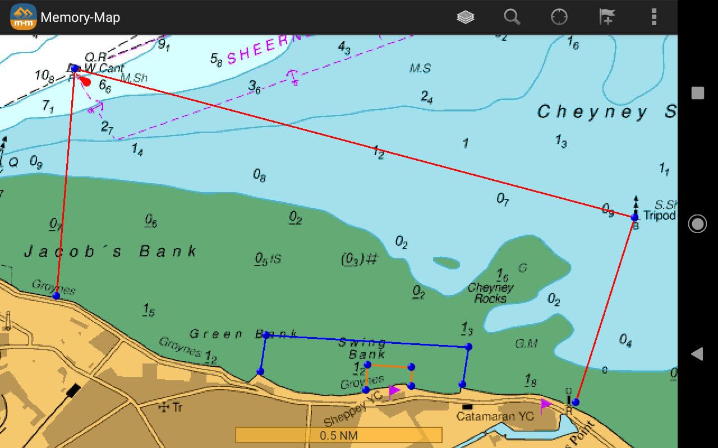

**Launching and Recovery**

Please refer to SOP2 Rescue Boats and SOP3 Recovery vehicles for information on there correct usage

When winds dictate a lee shore then every safety precaution must be exercised when launching and recovering boats. Boats may have to be moved onto the shingle if the tide allows, giving more space for the learners. Training may be postponed and/or abandoned, if launching and recovery is not achievable; the decision **will** be made by the Chief Instructor.. Assistance may be needed for cadet sailors launching and coming back onto the beach during a lee shore..

**Safety Boats Ratio to Dinghies*/* Multihulls**

Dinghies, Multihulls capable of recovering from swamping:

Up to 6 dinghies - 1 safety boat

7 to 15 dinghies - 2 safety boats

More than 15 dinghies - 3 or more safety boats

**Instructor Ratio for Dinghies*/* Multihulls**

**Crewed Dinghies**

3:1 for beginners with instructor on board Maximum

9:1 but not more than 6 boats per instructor (e.g. 3 Wayfarers with 3 students in each or 4 Picos each with 2 students in each)

**Single handed dinghies**

6:1 (applies only whilst the boats are used as single handers)

**Assistant Instructors**

Assistant Instructors count as qualified in the ratios set out above up to level 2 but must work under the direct supervision of an Instructor or Senior Instructor

**Instructor Ratios for Powerboat**

3:1 Level 1 & 2

6:1 Safety Boat over two boats

**Recovery of Power Boats and training Boats**

- Recover all marks that have been laid.

- Tractor Driver is approved

- Ensure recovery is safe and within operating procedures (S002) and best practices. - Boats ARE NOT to be driven onto trailers.

- Boats are tied on with a painter as well as winch strap.

- Ensure all training boats are de-rigged, washed down and stored correctly.

- Any buoyancy aids and helmets to be rinsed in fresh water and stored correctly

**End of Day**

Safety boats have been washed down.

- Engines have been flushed out with fresh water.

Fuel tanks have been topped up (at Bosun's discretion).

Check around the boat for damage.

- Sign rescue boat log sheet.

Ensure all radios are back on chargers.

- Ensure flags are removed from the mast on top of the tower.

- Secure garage doors.

Lock all other doors to club

- Close the security gate.

**VHF Radio**

Use channel 37/M1

All radio conversations are to be kept short and to the point. Proper etiquette shall be exercised when having two-way, radio telephony interaction. Call signs are issued at the beginning of the day by the chief instructor using the format below:

**Call signs**:

| Tower | Shep Base |
| --- | --- |
| Humber | Shep One |
| Raptor | Shep Two |
| Wetline | Shep Three |
| RS Vision 1 | Shep Vision 1 (with instructor) |
| RS Vision2 | Shep Vision 2 (with instructor) |

Please note our call sign is 'Shep' (NOT 'Sheppey' which refers to someone else)

**Guidelines**:

Set the safety boat radio to maximum volume & place inside a waterproof Aquapac Test radio communication using practice calls

Keep messages brief and to the point

Hold the radio vertically

Speak as clearly as you can

**Radio Procedure:**

The initiator of a call first attracts the attention of the intended recipient by saying clearly:

**"SHEP ONE, SHEP ONE, this is SHEP BASE, SHEP BASE, Over**”.

The person called acknowledges:

**"SHEP BASE this is SHEP ONE Over"**

The initiator then passes the message:

**"SHEP ONE, <message>, Over"**

The receiver responds:

**"SHEP BASE, <answer>, Over"**

Calls are exchanged in this way until the conversation is complete, when the final communications are ended simply "**Out**" (NEVER over and out).

If an intended recipient is busy, there should still be a brief response to indicate why taking a message at the time is inappropriate.

ALWAYS respond when an emergency may have arisen. If you are actively dealing with an emergency, make a minimal reply to this effect when you first can, and follow up as soon as possible.

**CHANNEL 16 MUST NOT BE USED FOR ANY REASON EXCEPT DISTRESS WORKING**

**Learners**:

The Club offers training to a range of ages from Cadets to Adults. When performing cadet training all parents/guardians will have a signed consent form allowing the club to perform the training. There is also an option for the parent/guardian to sign allowing photographs to be used for publicity).

**Missing Persons**

All cadets must be signed in on the morning of the training, and signed out before leaving at the end of the day. Head counts are performed at the end of each session to ensure all learners are safe and well. Should a learner to be found to be absence, then the Chief instructor should be informed immediately and the procedure below should be adhered to:

**Procedure**

If a child goes missing during training the IOSSC will apply the following procedure:

• Ensure that all other children continue to be supervised appropriately off the water while a search for the child concerned is carried out.

• Organize the remaining available responsible adults to conduct a search of the surrounding area allocating each individual to a specific area. Request all those searching report back within a short time, dependent on the size of the area being searched.

**•** If the child cannot be found after a good search of the immediate surroundings, contact the child's parents to advise them of the concern and reassure them that everything is being done to locate the child.

•

Report the incident to the designated safeguarding officer.

• Make a note of the circumstances in which the child has gone missing and where he/she was last seen and prepare a detailed physical description of the child, to include their hair and eye colour, approximate height and build and clothing he/she was wearing, as this will be required by the police.

• Report the concern to the police **if** the search is unsuccessful and no later than 20 minutes after the initial missing person report if the search is ongoing.

• Follow police guidance if further action is recommended and maintain close contact with the police.

• Ensure that you inform all adults involved including the parents, searchers and police if at any stage the child is located.

Process flowchart: If a cadet appears to be missing, the flow chart below identifies the process to be followed. There may well be access to photographs of all young people at the event and if so these can be used to help provide the police with a description should this be necessary.

| Young person is noticed to be missing |
| --- |
| Staff assemble in conjunction with IOSSC Safeguarding officer to asses the situation. If child seen entering a car then contact police, otherwise conduct search of appropriate area. Do not send other young people to search |
| The IOSSC Safeguarding officer will make the decision to contact the police and will inform the parents. |
| Incident to be logged and discussed. Any learning to be taken forward. |