

STANDARD OPERATING
PROCEDURES

Power Driven Vessels

Identifying Number | Review Date
S-002 | 1st January 2016

INCORPORATING

- Rescue Boats
- Maintenance of Marine Combustion Engines

This SOP has been produced to satisfy the administration of IOSSC and future legislation which may be enforced at a later date by the governing body.
I.O.S. Sailing Club
Marine Parade
Sheerness
Kent ME12 2BE
01795 663052
info@iossc.org.uk

PURPOSE - This SOP is to acquaint the persons in the use of club motor boats.

SCOPE - This SOP applies to the individuals that have been nominated to use club motor boats for Training, Rescue service and/or recreational use.

RESCUE BOATS

Introduction

The Isle Of Sheppey Sailing Club (IOSSC) operates a range of different type of motor propelled vessels used or capable of being used as means of transportation on water. Every vessel has its own characteristics and modes of operation. Mainly stored on purpose built trailers some vessels may require mooring over a period or require special launching and recovery procedures. IOSSC owns three Ridged Hull Inflatable Boats (RHIBs), and regularly uses private or commercially owned craft. This SOP outlines the basics of operation and should be used in conjunction with manufactures instructions and/or owners requests. See ANNEX 2 for start up guide.

Preparation

All boats are to be made ready be the designated crew in good time prior to any activity on the water. Equipment should be in good working order and checked iaw manufactures instructions. Additional equipment such as that used for rescue purpose is to be collected and secured in the boat. A list of equipment can be found inside the club in the designated area. Outboard engines are to be tested prior to leaving the compound using the flush muffs and fresh water or a suitable container which submerges the leg of the outboard engine above the vacuum plate.
Marker buoys are to be placed in the rescue boat with securing arrangements stored in an appropriate container which will not damage the rescue boat when operating at high speed and/or in heavy weather conditions.

Operators are to ensure that sufficient fuel is placed in the boat for that days activity. If more fuel is required then arrangements are to be made in order to replenish fuel stocks at an appropriate time.

Keys and VHF radios are to be collected from the charging area and tested prior to proceeding afloat.

Any damaged sighted to the boat is to be reported immediately and logged so that temporary repairs can be effected. If temporary repairs are not suitable then another rescue boat is to be sourced.

Launching

Whenever a RHIB or other vessel, which is traditionally stored on a purpose built trailer requires launching, the crew, directly responsible to the Officer Of the Day (OOD) are to make ready the vessel with all its associated equipment and any additional items.

A suitable number of persons or an appropriate vehicle is to be used for hauling the boat up the slip way and/or down to the beach. If a vehicle is used then a trained driver MUST operate it, understanding its limitations. The boat is to be backed into the water in a controlled manor and should be free from persons inside and behind. A member of the crew is to hold the painter to ensure the craft does not float away when detached from the trailer. The crew are to clear the boat away from the trailer to a safe distance so that the trailer may be hauled clear of the water and parked in an appropriate area.

General Operation

All operators are to have completed an appropriate RYA power boat course. A minimum of Power Boat Level 2 is required to operate club boats.
All coxwains are to have due regard to the conditions that the boat can operate in and if at any time the coxwain feels unsafe or that conditions are unsuitable he is to report to the OOD immediately.

Techniques for rescue and manoeuvring are in accordance with RYA National Power Boat qualification doctrine.

Speed Limits

All RHIBs operated at IOSSC are capable of high speeds and coxwains are to be aware of local bye laws which warrant speed limits within a distance from shore, especially in designated bathing areas or in proximity to marinas or mooring areas.

Rescue boat crews are to respond to a capsize or emergency immediately and be on scene as quickly as possible. If multiple accidents/capsizes are presented then they are to proceed to the scene which presents the highest danger taking into account the type of vessel(s) involved, the experience of the crew and the proximity to danger. The priority of the coxwain is as follows:
- Life
- Environment
- Property.

At certain states of tide there is in-sufficient water to allow high speed manoeuvres and operation. At IOSSC the limiting height of tide is 1.5 meters. This is visually recognised when the NUB on the outer pole is visible above the waterline. Under no circumstances is any rescue boat to proceed inshore at high speed and if necessary take all way off and paddle or walk the boat to the shore.

Persons breaking this rule and cause damage may be required to pay for any repairs or maybe subject to disciplinary under rule 43 of the constitution.

Recovery

The rescue boats are to be the last boats on the water after a days events unless specifically approved by the OOD or other competitors who wish to sail outside normal operating hours acknowledge the risk.

Boats are to be driven to the shore side and manually held in place by the crew whilst the nominated driver or sufficient number of handlers are free to manoeuvre the trailer. The trailer is only to be partially submerged so as to give easy access to the winch.

NO ONE IS TO STAND BEHIND THE TRAILER AND/OR BOAT

Boat crews are to ensure that the engine is fully tilted up so that the propeller is clear of the water so far as possible.

The boat is to be hand manoeuvred to the trailer and winched on securely.

UNDER NO CIRCUMSTANCES IS THE BOAT TO BE DRIVEN ONTO THE TRAILER

Post Sailing

Once all water activities are completed and the boats are back in the club compound they are to be hosed off and whipped down moving all salt deposits. Buoys and chains are to be cleaned and re-stowed in the buckets and placed in the allocated area. Ensure that portable VHF radios are switched off and returned to the charging area. If a fixed system is installed it is switched off and the aerial lowered.
After every outing, flush out the engine. This doesn’t just apply to salt water outings but to fresh water as well. If the lake or river you operate on isn’t as clear as the water from your garden hose you need to flush. If you ran aground and kicked up some sand, you need to flush. It won’t take long, ten to fifteen minutes, and during that time you can check out some other items.
To flush the engine you will need a set of "rabbit ears" or “flush muffs” (two flexible rubber seals connected with a metal clamp). Simply slip this apparatus onto the lower unit where the water is picked up and attach a garden hose. Start up the engine and let the water pump do the rest. (Be sure to stay clear of the prop and make sure no one tries to shift into gear)
While the motor is being flushed, check the water pump to make sure you have good water flow. Carefully put your finger through the stream of water. It may be warm, but it shouldn’t be hot. If the output is not strong, you may have some debris stuck in the outflow tube. You should immediately shut down the engine to prevent overheating and damage. A small piece of wire or similar object can be inserted up into the flow tube and worked back and forth. Start the engine again and check the output. If that doesn’t solve the problem you may need a new water pump.
After flushing the engine, you should disconnect the fuel line and allow the engine to burn all the fuel in the carburettor. By the way, make sure you always use fresh fuel. You should not use fuel that has been sitting around for over 60 days. That means; at the end of your season take the fuel in your tanks to the proper recycling authority. Don’t save it up for next year. That's an invitation for disaster. Other fuel related items you should check are:
• Check the fuel line for cracks and worn spots
• Make sure the fuel primer bulb is not cracked and is pliable
• Make sure the fuel line fittings seat properly and don’t leak
• Check the clamps on the fuel line for rust or corrosion
• Check the fuel tanks for damage and corrosion
• Check the tank vent to make sure it aspirates properly (many a mechanic has handed a boater a bill for services after he simply opened the tank vent)
• Check for water in the fuel

Once you have finished the flushing and run the engine out of fuel, be sure to turn off the key and, if you have a battery switch, turn it off. Open up the engine cover and check for fuel or water leaks. If you find leaks you should consult the bosun. Be sure to wipe everything down and spray with a anti-corrosive like WD 40 or Quick-lube. Be sure to lubricate all the moving parts such as the shift and throttle cables, carburettor valves etc. Check manufactures manual for details.

TYPE SPECIFIC
All Boats
When preparing any of the IOSSC safety boats the basic 6 POINT CHECK (Annex 1) should be followed.
      - EQUIPMENT: Ensure all equipment is stored and secured in the boat prior to launching. Each boat will be equipped with a minimum of:
- Paddle(s)
- First Aid Kit
- Spare Kill Cord
- Knife and/or Bolt Croppers
- Flares
- Pump
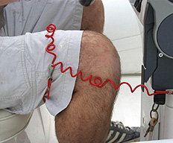
- Tow Line

      - KILL CORD: Each safety boat is fitted with a kill cord and as the name suggests is a piece of cord designed to kill your engine in the event of you going overboard. One end of the kill cord is attached near the throttle and the other should go around the helmsman’s leg or buoyancy aid/lifejacket. IOSSC recommend that the kill cord is located above at least two joints of the human body i.e above the knee. A kill cord should never be worn around your wrist.

      - RADIO: The Humber RHIB at IOSSC has a fixed radio installation. You should ensure that it is set to Ch 37 and on Low Power. If you do not have a fixed radio then a hand held radio will be required from the OOD/RO located in the Tower. A RADIO CHECK SHOULD BE COMPLETED PRIOR TO LAUNCHING.

      - FUEL: All safety boats are petrol driven with a separate oil tank located within the engine. Crews are to ensure that the fuel tank is full and the VENT on the tank is open. When refueling any tank you are to ensure that a filtered funnel is used and any dirt and/or water does not enter.

      - BUNG: Not withstanding “self draining or one way valves” bungs or plugs should be inserted prior to launching to stop the ingress of water into the Hull and/or cockpit

      - Log Sheet: Once all above checks and a visual inspection of the safety boat are complete the log sheet should be completed making note of the “hours run”.

Annex 1
6 Point Check
S002

NO MATTER WHAT BOAT!

Pre Departure 6 Point Check

- EQUIPMENT
- KILL CORD
- RADIO
- FUEL
- BUNG
- LOG SHEET
ANNEX 2
Start Up Procedure – Humber 40Hp
S002

HUMBER

On Shore Prior to Sailing (in the compound).
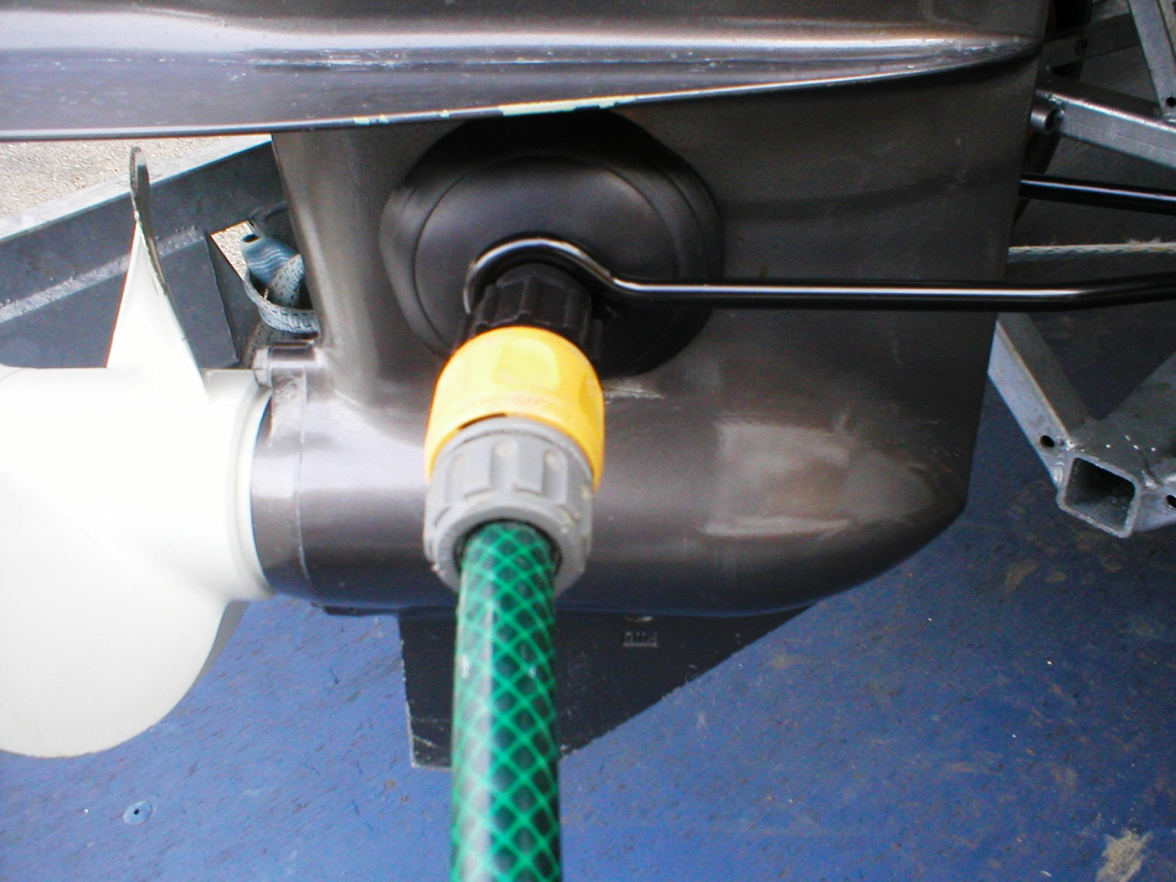
            - Ensure water hose is extended with no kinks.
            - Connect Hose to Flush Muffs.
            - Place around the Lower part of the engine, ensuring that the water intakes are covered. (See Diagram).
            - Turn on water supply.
            - Prime the Fuel Bulb until hard.
            - Lift “warm up Lever” all the way.
            - Push Key in (This activates the choke) and listen for “click” noise.
            - Turn Key so Starter Motor engages. (N.B – Stop After 5 Seconds)
            - Once engine has started let go of the key to dis-engage the starter motor.
            - The engine will REV very high! Lower the warm up lever.
            - Ensure that a stream of water can be seen leaving the engine (VERY IMPORTANT).
            - Turn Off Engine.
            - Switch off Water supply.
            - Remove Flush Muffs.
            - Load any additional items such as Buoys and/or Anchors.
            - Tilt Engine up and tow to Launching area.

Once Launched and in the Water.

- Ensure sufficent water around the boat and engine.
- Lower Engine appropriately.
- Turn Key to start. (N.B THERE SHOULD BE NO NEED TO CHOKE OR USE THE WARM UP LEVER).
- Clear the Beach Area and follow instructions from OOD/RO or as briefed.
ANNEX 2
Start Up Procedure – Wetline 20Hp
S002

WETLINE

On Shore Prior to Sailing (in the compound).
            - Ensure water hose is extended with no kinks.
            - Connect Hose to Flush Muffs.
            - Place around the Lower part of the engine, ensuring that the water intakes are covered. (See Diagram).
            - Turn on water supply.
            - Prime the Fuel Bulb until hard.
            - Lift “warm up Lever” all the way.
            - Push Key in (This activates the choke) and listen for click noise.
            - Turn Key so Starter Motor engages. (N.B – Stop After 5 Seconds)
            - Once engine has start let go of the key to dis-engage the starter motor.
            - The engine will REV very high! Lower the warm up lever.
            - Ensure that a stream of water can be seen leaving the engine (VERY IMPORTANT).
            - Turn Off Engine.
            - Switch off Water supply.
            - Remove Flush Muffs.
            - Load any additional items such as Buoys and/or Anchors.
            - Tilt Engine up and tow to Launching area (TO TILT THE ENGINE THE CONTROL BOX MUST BE PUT INTO FORWARD GEAR)

Once Launched and in the Water.

- Ensure sufficent water around the boat and engine.
- Lower Engine appropriately.
- Ensure Control Box is set to Neutral.
- Turn Key to start. (N.B THERE SHOULD BE NO NEED TO CHOKE OR USE THE WARM UP LEVER).
- Clear the Beach Area and follow instructions from OOD/RO or as briefed.
ANNEX 2
Start Up Procedure – Avon 30Hp
S002

AVON

On Shore Prior to Sailing (in the compound).
            - Ensure water hose is extended with no kinks.
            - Connect Hose to Flush Muffs.
            - Place around the Lower part of the engine, ensuring that the water intakes are covered. (See Diagram).
            - Turn on water supply.
            - Prime the Fuel Bulb until hard.
            - Lift “warm up Lever” all the way.
            - Pull out choke.
            - Pull Slack from “Pull Start”.
            - Ensure you are securely stood or sat down. Give a large pull on the rope. Repeat no more than 3 times.
            - Push in choke whether the engine is running or not! The engine will REV very high if started, Lower the warm up lever).
            - Ensure that a stream of water can be seen leaving the engine (VERY IMPORTANT).
            - Switch Off Engine.
            - Switch off Water supply.
            - Remove Flush Muffs.
            - Load any additional items such as Buoys and/or Anchors.
            - Tilt Engine up and tow to Launching area (Tilt latch located on the front of engine under the handle)

Once Launched and in the Water.

- Ensure sufficent water around the boat and engine.
- Lower Engine appropriately and ensure tilt latch is in the up position. (See Note)
- Ensure Control Box is set to Neutral.
- Pull to start the engine. (N.B THERE SHOULD BE NO NEED TO CHOKE OR USE THE WARM UP LEVER).
- Clear the Beach Area and follow instructions from OOD/RO or as briefed.

NOTE: If the Tilt Latch is down then when you go astern the engine will tilt resulting in possible damage to the engine and/or the transom. In addition you will not get any stern power as the engine is out of the water.

